Syed Abid Ali Shah
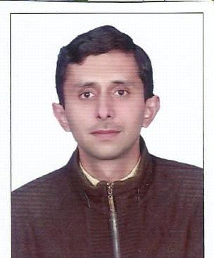

Cell # +92-3119613074
Permanent Address: Old Electric Complain Office Near Naasti House Madina Market Ward 27 Muzaffarabad Azad Kashmir
OBJECTIVE:
Seeking a challenging career oriented position in a dynamic organization, which provides an opportunity for achievement that allows me to utilize my skills, knowledge and experience and let me to testify my competency, industriousness and confidence with greater responsibility.
PERSONAL INFORMATION:
Father Name : Syed Ashraf Ali Shah
Date of Birth : 16-05-1981
Gender : Male
Marital Status : married
District : Muzaffarabad
Nationality : Pakistani (Kashmiri)
Religion : Islam

ACADEMIC EDUCATION:
DEGREE | BOARD / UNIVERSITY
Matric | AJK Mirpur Board
:N.I.C. # | 82203-1208760-9

LANGUAGES:
- English
- Urdu
- Hindko & All local languages.

REFERENCES:

Will be provided on demand.
Experience:, I Have 15 years hardware paint, iron, steel, sanitary, Wholesales and all kind of shop as a salesman worker experience

